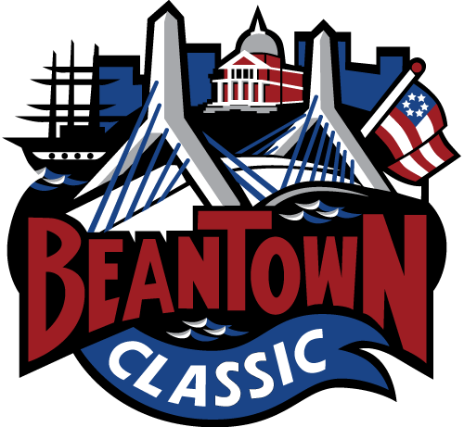

Beantown Classic To Welcome NextGEN AAA Team, Entirely Consisting Of Players Of Color

The Beantown Classic tournament organization will make history this coming weekend in Exeter, N.H., as the tournament welcomes the NextGEN AAA Foundation (Advancement In Athletics and Academics) Hockey team for its Beantown Summer Classic, to be run Aug. 8-11 in Exeter, N.H.

The NextGEN AAA Foundation squad will field a team entirely consisting of black and brown players from the United States, Canada and Great Britain. The Foundation was founded by Dee Dee Ricks, a philanthropist and self-described Hockey Mom. Coaching the NextGEN AAA team in Exeter will be New Jersey Devils Assistant Coach and former Boston University and NHL player Mike Grier, as well as former NHLer Bryce Salvador, NextGEN AAA’s NHL Alumni Ambassador.

“As someone who makes his living in the sport of hockey, any opportunity to help grow the sport is what we are all trying to do,” said Beantown Classic Founder and President Peter Masters. “I am always looking to help nourish any initiative to get more athletes involved in this great sport.”

“I am extremely happy and grateful to work with this group of young and talented players,” said Mike Grier, in a NextGEN AAA Foundation release. “Thank you to NextGEN and the National Hockey League for supporting the development of minority players pursuing their dreams.”

“NextGEN provides youth hockey opportunities and experiences for young men of color that I wish I had when I was growing up in the game,” said Bryce Salvador. “The game of hockey continues to increase the number of diverse players with the talent and skill to compete in college, in the minors, and the NHL, and supporting organizations like NextGEN, who develop those pathways, is vital.”

The National Hockey League (NHL) and Pure Hockey will sponsor the team.

“NextGEN is carving out a pipeline of diverse, elite-level hockey talent,” said Kim Davis, Senior Executive Vice President of Social Impact, Growth Initiatives and Legislative Affairs at the NHL. “We believe in the near future more teams across the continent will feature more players of color, and this NextGEN team is a strong signal that we are moving closer to that day.”

The Beantown Classic’s Masters - a former Boston College player - recalls when he was first contacted about the possibility of NextGEN AAA Foundation’s team joining his event.

“The Beantown Classic is in its 17th year and this is the first time we have allowed a pre-rostered, full team to participate in this event. We have always had 350-400 individual entry athletes register through a stringent evaluation process and then place them on teams to compete each August,” Masters said.

“I received a call from Brett Peterson, who is a full-time NHL agent,” Masters added. Peterson is an advisor/consultant to the Foundation. “He explained the genesis of the team and the goals and that he has worked with this group the past two summers and he then pitched them joining our event for the first time. When presented with the goal of NextGen and the team they wanted to bring, it was a no-brainer for us to include them in our event as presented.”

Team recruitment was led by Rod Braceful, the Assistant Director of Player Personnel for USA Hockey’s National Team Development Program.

“I’m extremely honored to assist the NextGEN Foundation and support minority players and families navigating elite levels of the game,” said Rod Braceful. “It was a similar organization in Detroit that fueled my love for the game and role models like Mike Grier and Bryce Salvador who inspired me and many others to find a career path in hockey.”

The NextGEN AAA Foundation’s mission is to improve the lives of student-athletes – primarily through academic and athletic intervention – while striving to create an all-inclusive environment in youth hockey. The Foundation was founded by Dee Dee Ricks in 2017, a philanthropist and self-described hockey mom. NextGEN has provided over $1mm in scholarships to support student-athletes of color at some of the leading preparatory schools, colleges, and travel hockey programs throughout North America.

“This is our third year bringing together some of the top diverse student-athletes in North America and Great Britain to compete in the Beantown tournament,” said Ricks. “Our roster represents just how far we have come in less than a decade, thanks to people like Rod, Mike and Bryce and the generosity of the NHL and Pure Hockey.”

Inquiries or interview requests can be directed to Joshua Boyd (joshboyd3@yahoo.com).

More information on the NextGen AAA Foundation is available at www.nextgenaaa.org or by contacting deedee@nextgenaaa.org.

