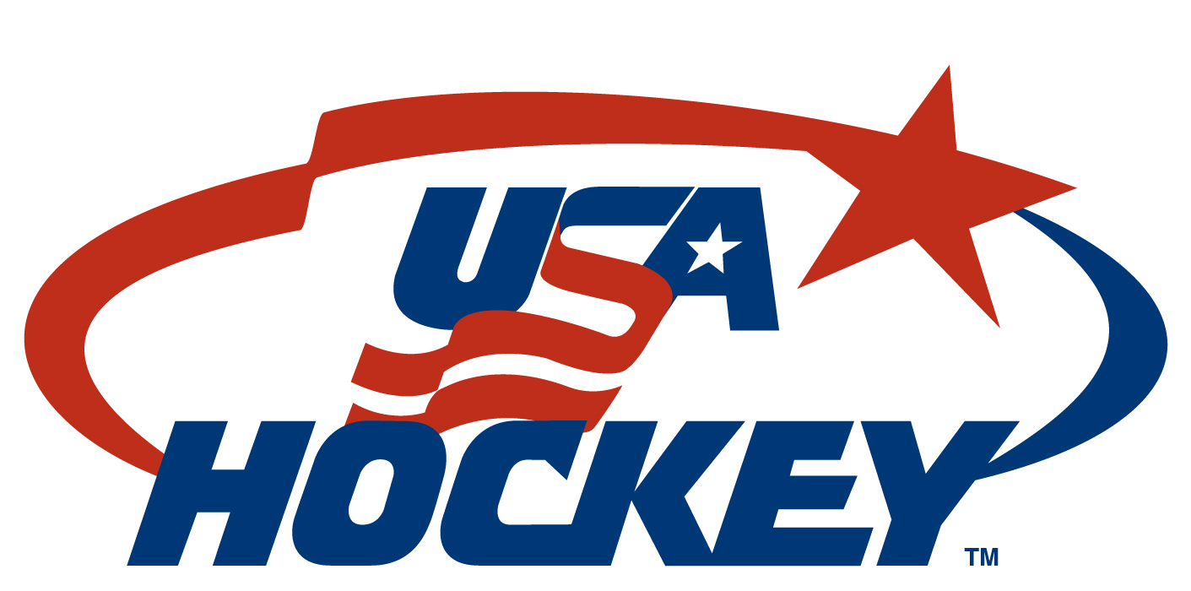
2009 United States Junior Select Team Roster

No. Name Ht (cm) Wt (kg) Birthdate S/C Hometown 2009-10 Team/NHL Rights
GOALTENDERS (2)
30 Eric Mihalik 6-0 (183) 180 (82) 2/28/91 L Avon Lake, Ohio Des Moines Buccaneers (USHL)
1 Will Yanakeff 6-3 (191) 200 (91) 4/30/92 L Jerome, Mich. Sioux City Musketeers (USHL)

DEFENSEMEN (7)
4 Kevin Albers 6-0 (183) 191 (87) 5/23/91 R Lake Orion, Mich. Green Bay Gamblers (USHL)
7 Mac Bennett 5-11 (180) 175 (79) 3/25/91 L Warrick, R.I. Cedar Rapids RoughRiders (USHL)/Montreal
8 Kevin Gravel 6-4 (193) 185 (84) 3/26/92 L Kingsford, Mich. Sioux City Musketeers (USHL)
6 Nick Jensen 6-0 (183) 195 (88) 9/21/90 R Rogers, Minn. Green Bay Gamblers (USHL)/Detroit
5 Kevin Lind 6-3 (191) 202 (92) 3/31/92 L Homer Glen, Ill. Chicago Steel (USHL)
24 Nick Mattson 6-1 (185) 190 (86) 10/25/91 L Chanhassen, Minn. Indiana Ice (USHL)
3 Eamonn McDermott 5-11 (180) 176 (80) 12/17/91 R Shaker Heights, Ohio Fargo Force (USHL)

FORWARDS (13)
15 Beau Bennett 6-1 (185) 180 (82) 11/27/91 R Gardena, Calif. Penticton Vees (BCHL)
22 Shane Berschbach 5-8 (172) 140 (64) 5/19/91 L Clawson, Mich. Indiana Ice (USHL)
20 Connor Brickley 6-0 (183) 190 (86) 2/25/92 L Everett, Mass. Des Moines Buccaneers (USHL)
11 Jeff Costello 5-11 (180) 202 (92) 11/20/90 L Milwaukee, Wis. Cedar Rapids RoughRiders (USHL)
9 Chris Crane 6-0 (183) 190 (86) 12/2/91 R West Chester, Ohio Green Bay Gamblers (USHL)
18 Derek DeBlois 5-10 (178) 176 (80) 2/19/91 R East Greenwich, R.I. Cedar Rapids RoughRiders (USHL)
17 Nic Dowd 6-1 (185) 182 (83) 5/27/90 R Huntsville, Ala. Indiana Ice (USHL)/Los Angeles
10 David Gerths 6-0 (183) 195 (88) 9/27/90 R Ankeny, Iowa Lincoln Stars (USHL)
14 Matt Leitner 5-10 (178) 172 (78) 11/27/90 L Los Alamitos, Calif. Fargo Force (USHL)
23 John Parker 5-10 (178) 180 (82) 1/11/92 R Green Brook, N.J. Indiana Ice (USHL)
16 Mike Parks 5-11 (180) 191 (87) 2/15/92 R O’Fallon, Mo. Cedar Rapids RoughRiders (USHL)
21 Nick Sorkin 6-3 (191) 170 (77) 6/30/91 L Rockville, Md. Waterloo Black Hawks (USHL)
19 Colten St. Clair 5-11 (180) 180 (82) 11/22/92 R Gilbert, Ariz. Fargo Force (USHL)

TEAM STAFF USA Hockey, Inc.
Head Coach: Mark Carlson, Cedar Rapids, Iowa President: Ron DeGregorio, Salem, N.H.
Assistant Coach: Jeff Blashill, Indianapolis, Ind. Executive Director: Dave Ogrean, Colorado Springs, Colo.
Assistant Coach: Andy Jones, Sioux Falls, S.D. Vice President, International Council Chairperson: Tony Rossi, Chicago, Ill.
Equipment Manager: Darrin Flinchem, Indianapolis, Ind. Chairman of the Board: Walter L. Bush, Jr., Edina, Minn.
Trainer: TBD Sr. Director, Hockey Development: Kevin McLaughlin, Colorado Springs, Colo.
Team Physician: Dr. Alan Ashare, Boston, Mass. Director, Communications: Dave Fischer, Colorado Springs, Colo.
USAH Staff Liaison: Marc Boxer, Colorado Springs, Colo.

10/19/09

