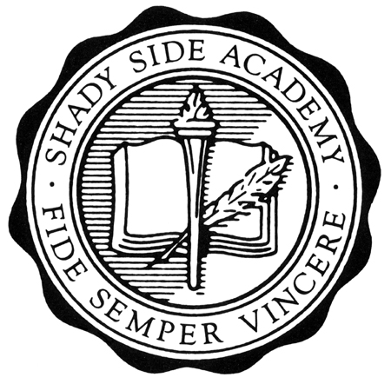
Shady Side Academy Thanksgiving Classic
November 29 – Dec. 1, 2013

Roy McKnight Division Richard Gregory Division

Linsly School Shady Side Academy
Northwood School University School
Wyoming Seminary Lawrenceville School

Friday November 29, 2013

8:00 am. Linsly School vs. Northwood School
10:00 am. Shady Side Academy vs. University School
12:00 pm. Lawrenceville School vs. Wyoming Seminary

2:45 pm. SSA Alumni Game

4:30 pm. Shady Side Academy vs. Lawrenceville School
6:30 pm. University School vs. Northwood School
8:30 pm. Wyoming Seminary vs. Linsly School

Saturday November 30, 2013

8:00 am. Lawrenceville School vs. Universityy School
10:00 am. Linsly School vs. Shady Side Academy
12:00 pm. Northwood School vs. Wyoming Seminary

6:30 pm. Semi Finals – Gregory Second Place vs. McKnight First Place
8:30 pm. Semi Finals- McKnight Second Place vs. Gregory First Place

Sunday December 1, 2013

8:45 am. Third Place Teams Consolation
11:00 am. Championship Game

* Home Team is listed second on the schedule and wears dark. Please be ready to play 15 minutes before your scheduled game time so we can keep on schedule.

