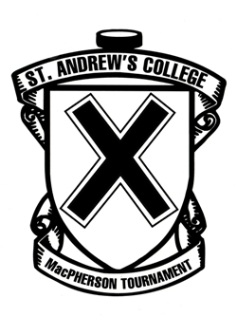
Apple
32nd Annual

Northwood School
St. Andrew's College
St. Francis High School
Ulysse Prep
HAMILTON DIVISION

Buffalo Jr. Sabres
St. Michael’s College
Upper Canada College Wyoming Seminary

MEAGHER DIVISION
St. Andrew's College
MacPherson Hockey Tournament

January 30 – February 1, 2015

Schedule of Games

FRIDAY, January 30

9:15 am | Upper Canada College vs. Wyoming Seminary | Aurora Community 2
9:30 am | St. Andrew’s College vs. St. Francis High School | La Brier Family Arena
9:30 am | Buffalo Sabres vs. St. Michael’s College | Aurora Community 1
9:30 am | Northwood School vs. Ulysse Prep | Aurora Rec East

12:30 pm Luncheon - St. Andrew's College - Great Hall

4:00 pm | Wyoming Seminary vs. Buffalo Sabres | La Brier Family Arena
4:00 pm | St. Michael’s College vs. Upper Canada College | Aurora Community 1
4:15 pm | Ulysse Prep vs. St. Francis High School | Aurora Community 2
7:00 pm | St. Andrew’s College vs. Northwood School | La Brier Family Arena

SATURDAY, January 31

9:30 am | Upper Canada College vs. Buffalo Jr Sabres | La Brier Family Arena
10:00 am | St. Michael’s College vs. Wyoming Seminary | Aurora Community 2
10:30 am | Northwood School vs. St. Francis High School | Aurora Community 1
11:30 pm | Ulysse Prep vs. St. Andrew’s College | La Brier Family Arena
6:30 pm | (1st Meagher) vs. (2nd Hamilton) | La Brier Family Arena
8:30 pm | (1st Hamilton) vs. (2nd Meagher) | La Brier Family Arena

SUNDAY, February 1

9:00 am | 3rd Hamilton vs. 3rd Meagher | La Brier Family Arena
9:00 am | 4th Hamilton vs. 4th Meagher | Aurora Community 1
11:00 am | Consolation Game | La Brier Family Arena
1:00 pm | Championship Game | La Brier Family Arena

First team listed is home team and will wear white

