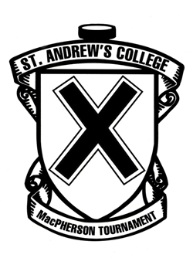
Apple

Bridgton Academy
Edge School
Jungadler Mannheim
St. Andrew's College

HAMILTON DIVISION

Jeannois College d’Alma
Northwood School
Seacoast Prep.
Upper Canada College

MEAGHER DIVISION
35th Annual
St. Andrew's College
MacPherson Hockey Tournament

January 26 – January 28, 2018

Schedule of Games

FRIDAY, January 26

9:15 am | Upper Canada College vs. Jeannois College d’Alma | Aurora Community 2
9:30 am | St. Andrew’s College vs. Bridgton Academy | La Brier Family Arena
9:30 am | Seacoast Prep. vs. Northwood School | Aurora Community 1
9:30 am | Jungadler Mannheim vs. Edge School | Aurora Rec East

12:30 pm Luncheon - St. Andrew's College - Great Hall

4:00 pm | Northwood School vs. Upper Canada College | La Brier Family Arena
4:00 pm | Edge School vs. Bridgton Academy | Aurora Community 1
4:15 pm | Jeannois College d’Alma vs. Seacoast Prep. | Aurora Community 2
7:00 pm | St. Andrew’s College vs. Jungadler Mannheim | La Brier Family Arena

SATURDAY, January 27

9:30 am | Northwood School vs. Jeannois College d’Alma | La Brier Family Arena
10:00 am | Jungadler Mannheim vs. Bridgton Academy | Aurora Community 2
10:30 am | Upper Canada College vs. Seacoast Prep. | Aurora Community 1
11:30 pm | Edge School vs. St. Andrew’s College | La Brier Family Arena
6:30 pm | (1st Hamilton) vs. (2nd Meagher) | La Brier Family Arena
8:30 pm | (1st Meagher) vs. (2nd Hamilton) | La Brier Family Arena

SUNDAY, January 28

9:00 am | 3rd Hamilton vs. 3rd Meagher | La Brier Family Arena
9:00 am | 4th Hamilton vs. 4th Meagher | Aurora Community 1
11:00 am | Consolation Game | La Brier Family Arena
1:00 pm | Championship Game | La Brier Family Arena

First team listed is home team and will wear white

