New England
Tier 1 15O, 16U and 18U
Regional Championship
November 8-10, 2019

Tier 1 15O, 16U and 18U
Regional Championship

On behalf of the Connecticut Hockey Conference (CHC), and our 39 member programs, we hope that all participating players and their families will enjoy their tournament experience not only this weekend, but for a lifetime!

Important reminder to all tournament players, coaches, parents, and spectators: CHC strictly adheres to the USA Hockey Zero Tolerance policy and Code of Conduct policy. Individuals can and will be requested to leave the facility if their behavior requires.

Quoting Bob Johnson, “It’s a Great Day for Hockey, so let’s play! Please join us in watching some great hockey.”

Rinks
New England Sports Center
121 Donald Lynch Blvd.
Marlborough, MA 01752
508-229-2700

Tournament Rules

Round Robin

Play will have 3 periods of 17 minutes for 15O and 16U and will have 3 periods of 20 minutes for 18U. Resurfacing Ice will be done at the beginning of the game and between 2rd and 3rd periods for the 15 and 16U games, and between each period for 18U games. Round Robin play will not have Overtimes or Time Outs. Unless otherwise agreed to by the teams and the Tournament Director, the Home Team shall wear light/white jerseys and the Visiting Team shall wear dark/colored jerseys in all games. The maximum number of players, excluding goalkeepers, shall not exceed eighteen (18). It is highly recommended that all teams arrive with two goalkeepers. Any team that cannot satisfy this requirement must notify the Tournament Director prior to the start of the tournament. Zero Tolerance will be enforced by all on and off Ice Officials. After round robin play, the four teams with the highest standing will advance to the Semi Final Round. There will be no consolation games.

** Tie-Break Procedures in Round Robin play.
If two or more teams have an equal number of points, their position in the standings shall be determined by the following tiebreaking format. If one tie-breaker establishes a position for one or more teams, each team is placed in the applicable position. Once a team (or teams) is placed, the remaining tied teams shall start the tiebreaking process over again at step 1. (If all tied teams have not played each other, then proceed to step 2. Note: a team may go into the tiebreaking process having defeated another of the tied teams and still not advance).

The tie-breaker formulas are as follows:
1. The results of the head-to-head games played between the tied teams in the following order:
a. Standings — Most points.
b. Most total wins.
c. Differential — Subtracting goals scored against from goals scored in these games, the positions being determined in order of the greatest surplus.
d. Quotient — Dividing the goals scored in these games by the goals scored against, the positions being determined in order of the greatest quotient. A quotient involving dividing by zero (0) has higher standing than a quotient from dividing by any number other than zero. Where two or more teams have no goals against and the quotient tiebreaker is required, the teams shall be ranked high to low in descending order of “goals for.”
e. Most periods won — In the games played by each tied team, points will be awarded for each regulation period won (2 points) and for each regulation period tied (1 point). Positions shall be in the order of highest point total.
Note: If a team forfeits any of its games, and becomes involved in any tie-breaking formula, the team that forfeited will not advance and all games played against the forfeiting team shall be recorded as 1-0 victories for all opposing teams.

2. If after applying the formulas of 1 a, b, c or d the tie still exists, the results of all the games played by the teams tied in the following order.
a. Most total wins.
b. Differential — Subtracting goals scored against from goals scored in these games, the positions being determined in order of the greatest surplus.
c. Quotient — Dividing the goals scored in these games by the goals scored against, the positions being determined in order of the greatest quotient. A quotient involving dividing by zero (0) has higher standing than a quotient from dividing by any number other than zero. Where two or more teams have no goals against and the quotient tiebreaker is required, the teams shall be ranked high to low in descending order of “goals for.”
d. Most periods won — In the games played by each tied team, points will be awarded for each regulation period won (2 points) and for each regulation period tied (1 point). Positions shall be in the order of highest point total.
e. Quickest first goal — The team that scored the quickest goal in their preliminary round games shall be ranked highest.

3. If the above procedure does not break the tie, the teams shall use a shootout procedure as previously described.

Note: Forfeits - If a team forfeits any of its games, and becomes involved in any tie-breaking formula to determine its eligibility to advance to the next level of play, the team forfeits all games in the round robin play and the games are recorded as 1-0 victories

Semi- Finals and Championships

Period time and Resurfacing will remain as round robin play. Each team will receive one time out in the regulation periods and one within the overtime (s), not per OT.
If tied at end of semi-final,
- There will be a 5 minute break; teams will remain at the same ends as the 2nd period, teams will play a 10 minute sudden death period.
- If teams are still tied after 1st OT, ice surface will be done and teams will play a 10 min. sudden death period.
- If teams are still tied after 2nd OT, teams will receive a 5 minute break and play a 3rd overtime 10 minute period.
- If teams are still tied after 3rd overtime, repeat 2 and 3 until a team wins.

 | New England District
15O Divisions & Schedule
American Division |  |  |  | National Division
Connecticut 1 - Wallingford |  |  |  | New Hampshire 1 – Seacoast Spartans
Connecticut 2 - Mid Fairfield |  |  |  | New Hampshire 2 – Northern Cyclones
Connecticut 3 – Junior Bulldogs |  |  |  | Rhode Island – RI Saints M
Friday, 11/8/19
Game # |  | Time | Rink |  | Home Team |  |  | Away Team
1 |  | 2:10 PM | 3 |  | Connecticut 1 |  |  | New Hampshire 2
2 |  | 2:30 PM | 6 |  | Rhode Island |  |  | Connecticut 3
3 |  | 2:30 PM | 8 |  | New Hampshire 1 |  |  | Connecticut 2

Saturday, 11/9/19
4 |  | 7:20 AM | 1 |  | New Hampshire 1 |  |  | Connecticut 1
5 |  | 7:30 AM | 3 |  | Connecticut 3 |  |  | New Hampshire 2
6 |  | 7:30 AM | 4 |  | Connecticut 2 |  |  | Rhode Island
7 |  | 2:40 PM | 3 |  | Connecticut 1 |  |  | Rhode Island
8 |  | 2:40 PM | 8 |  | Connecticut 3 |  |  | New Hampshire 1
9 |  | 3:40 PM | 7 |  | New Hampshire 2 |  |  | Connecticut 2
Sunday, 11/10/19
10 |  | 8:00 AM | 1 |  |  | #1 Seed | #4 Seed
11 |  | 8:00 AM | 2 |  |  | #2 Seed | #3 Seed
12 |  | 2:00 PM | 2 |  |  | Championship Game

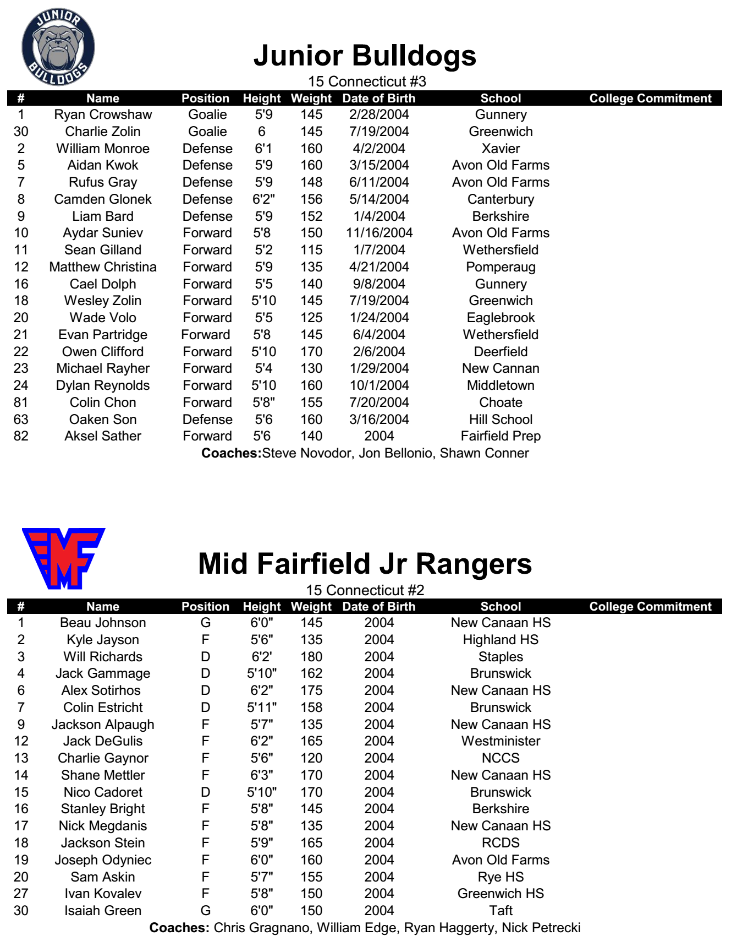

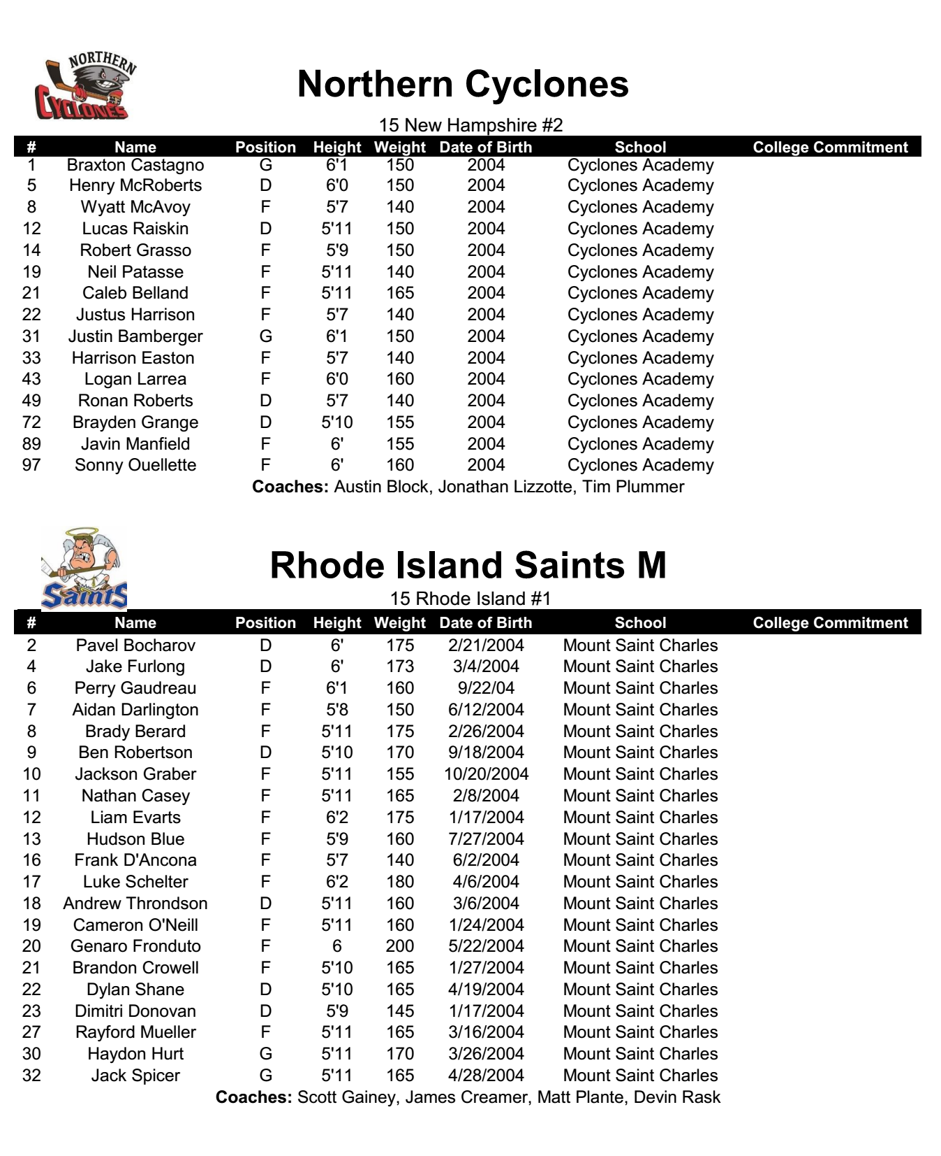

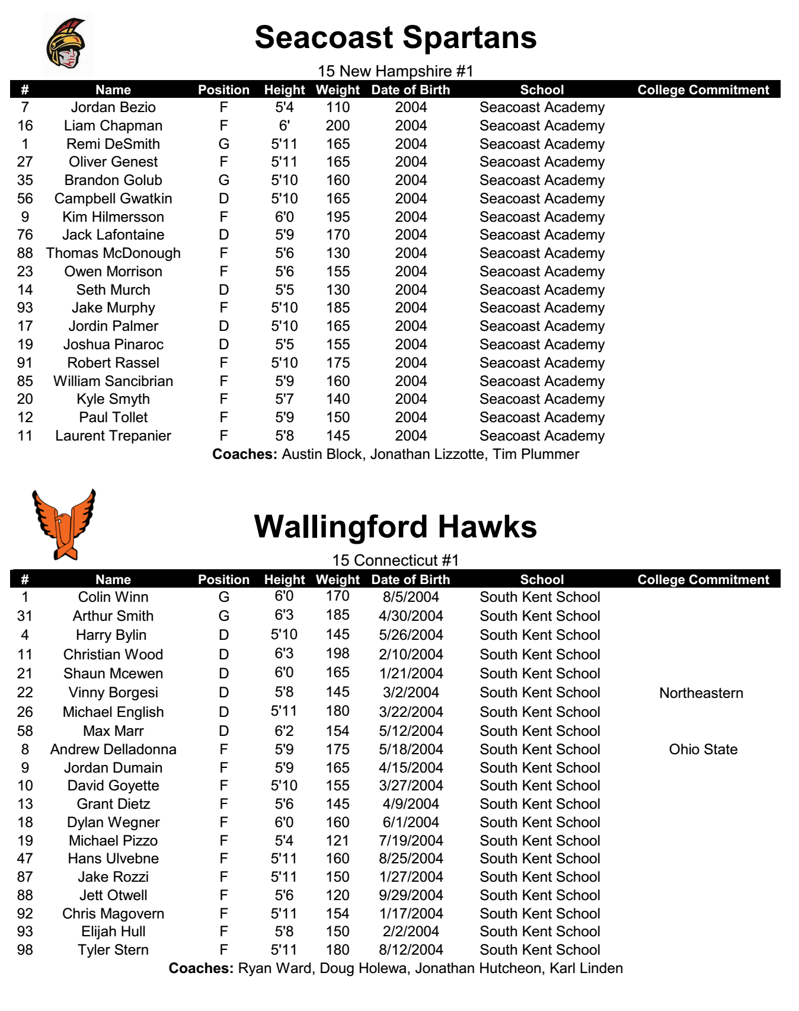

New England District
 | 16U Divisions & Schedule
 | American Division |  |  | National Division
 | Connecticut 1 – Wallingford |  |  | Rhode Island 1 – RI Saints M
 | Connecticut 4 – East Haven |  |  | New Hampshire 2 – Northern Cyclones 1
 | New Hampshire 1 – Northern Cyclones 2 |  |  | Connecticut 2 – Mid Fairfield
 | Rhode Island 2 – RI Hitmen |  |  | Connecticut 3 – Junior Bulldogs
 | Friday, 11/8/19
 | Game # | Time | Rink |  | Home Team |  |  | Away Team
 | 1 | 3:00 PM | 2 |  | Connecticut 1 |  |  | New Hampshire 1
 | 2 | 3:00 PM | 5 |  | Rhode Island 2 |  |  | Connecticut 4
 | 3 | 4:00 PM | 1 |  | Rhode Island 1 |  |  | Connecticut 2
 | 4 | 4:10 PM | 3 |  | New Hampshire 2 |  |  | Connecticut 3
 | Saturday, 11/9/19
 | 5 | 7:40 AM | 7 |  | Connecticut 4 |  |  | Connecticut 1
 | 6 | 8:10 AM | 5 |  | New Hampshire 1 |  |  | Rhode Island 2
 | 7 | 8:10 AM | 6 |  | Connecticut 3 |  |  | Connecticut 2
 | 8 | 8:10 AM | 8 |  | New Hampshire 2 |  |  | Rhode Island 1
 | 9 | 6:50 PM | 5 |  | Connecticut 1 |  |  | Rhode Island 2
 | 10 | 7:40 PM | 7 |  | New Hampshire 1 |  |  | Connecticut 4
 | 11 | 8:20 PM | 4 |  | Rhode Island 1 |  |  | Connecticut 3
 | 12 | 8:40 PM | 8 |  | New Hampshire 2 |  |  | Connecticut 2
 | Sunday, 11/10/19
 | 13 | 10:30 AM | 1 |  |  | AM#1 Seed | NA #2 Seed
 | 14 | 10:30 AM | 2 |  |  | NA #1 Seed | NA #2 Seed
 | 15 | 4:20 PM | 2 |  |  | Championship Game

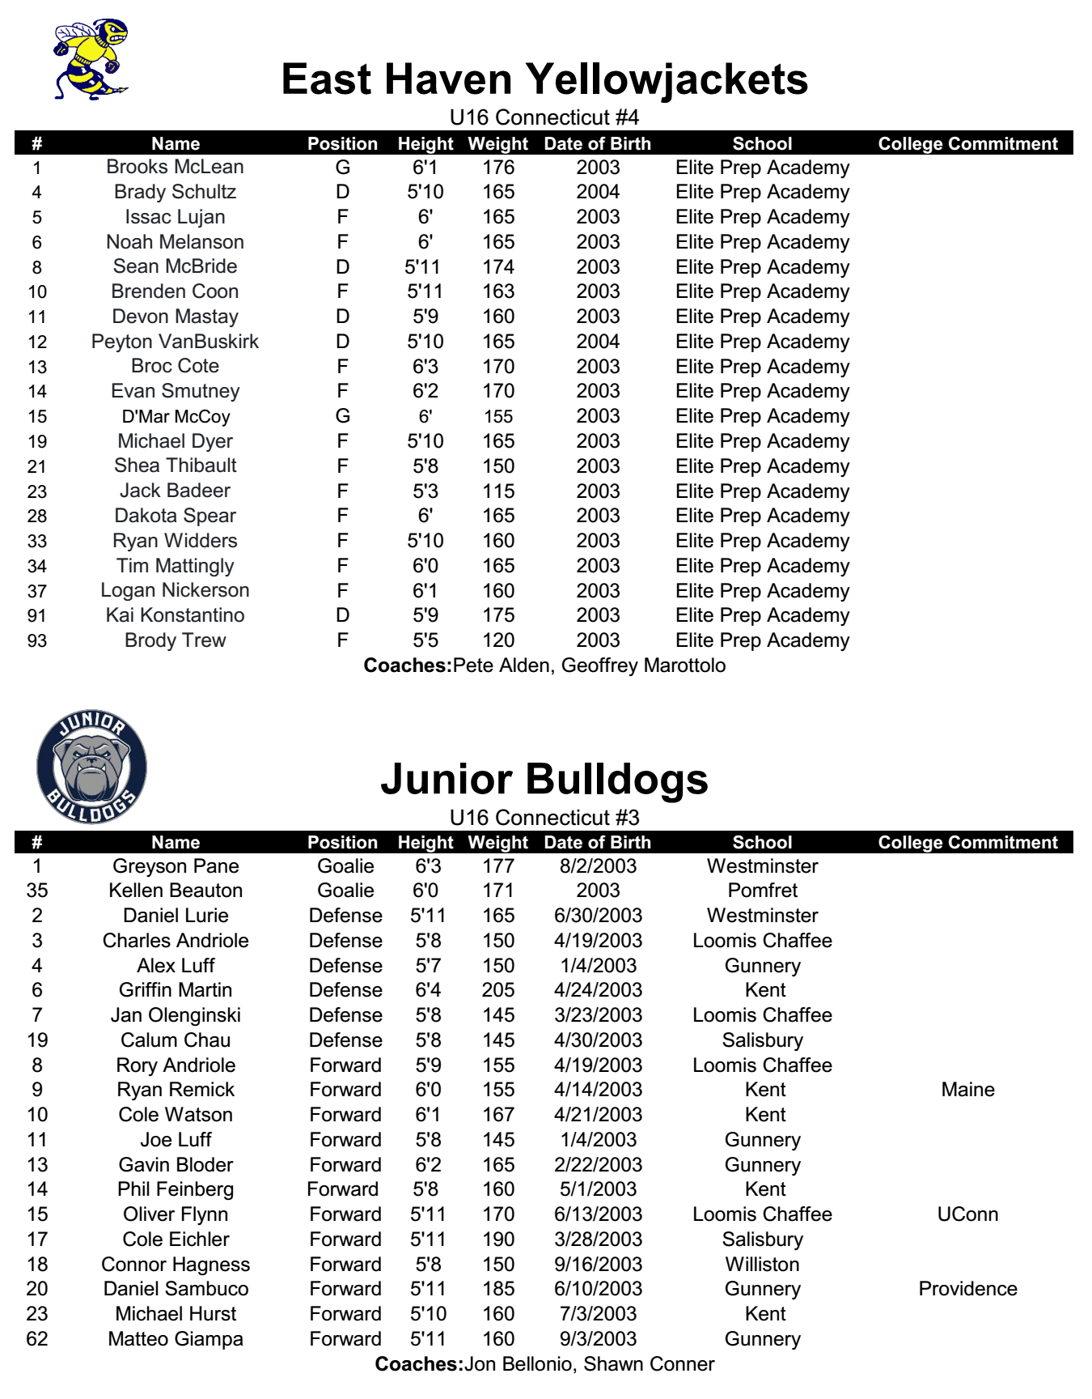

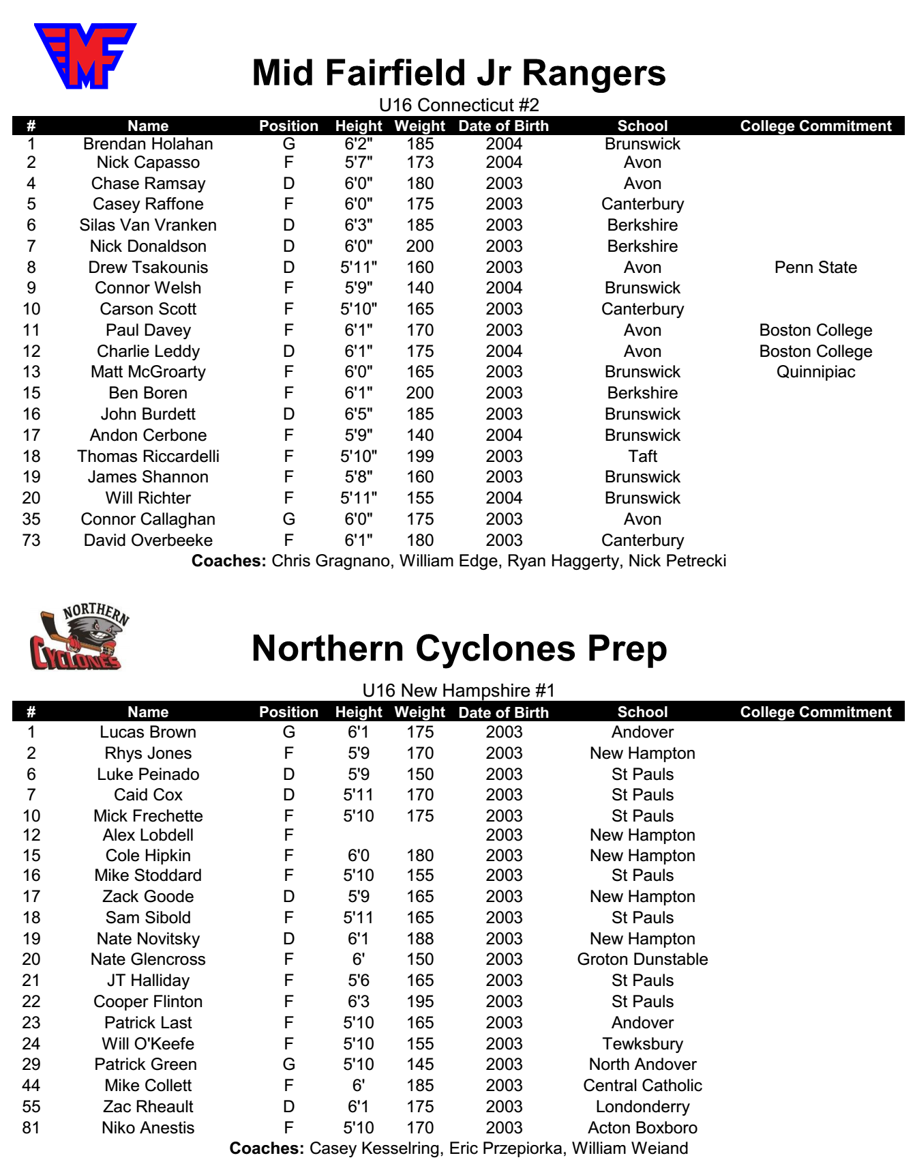

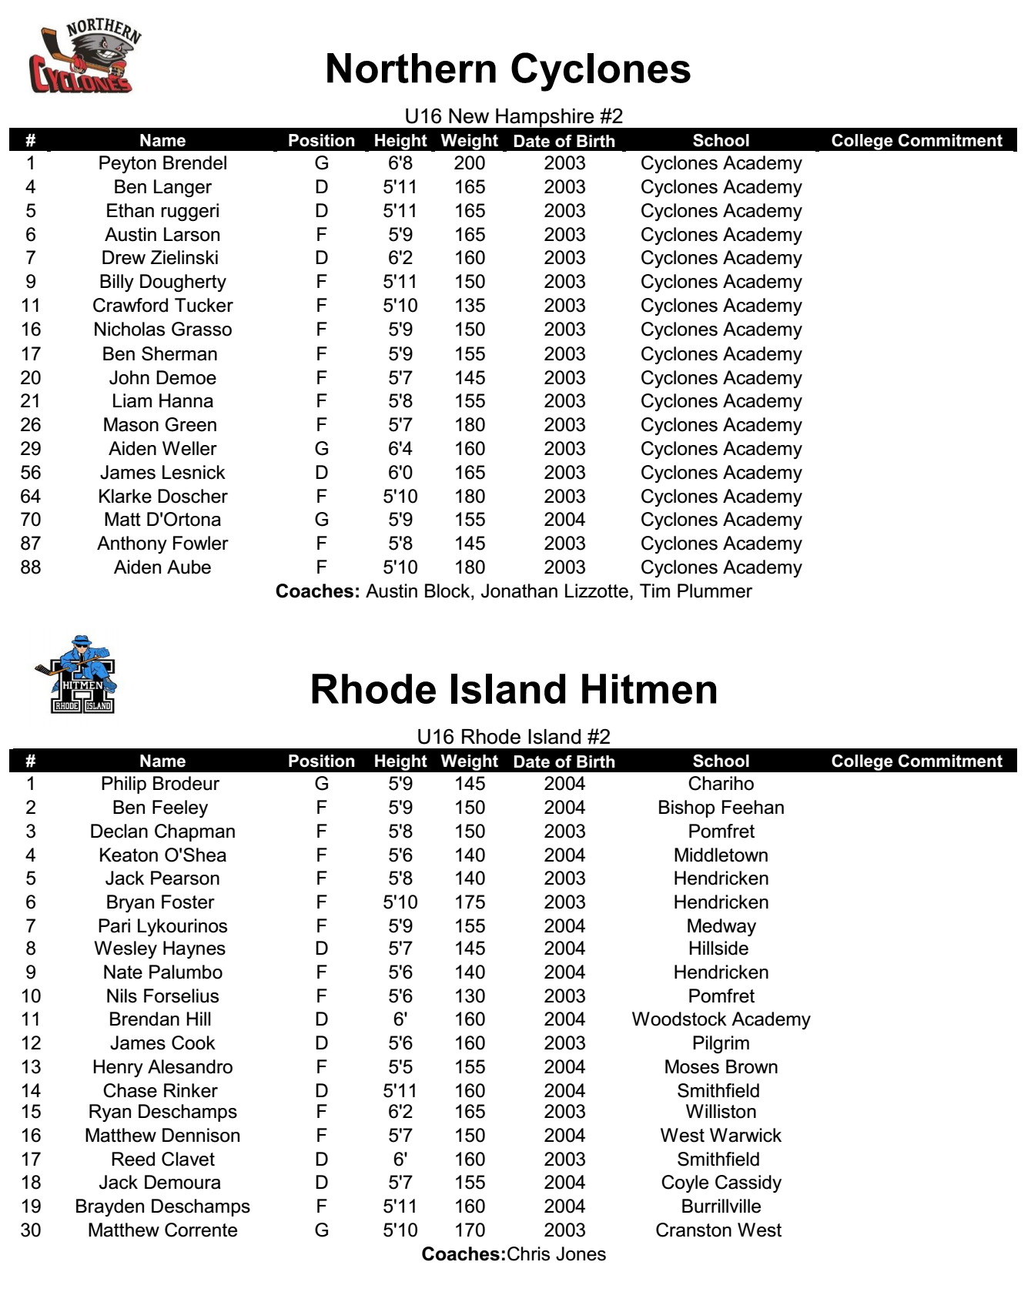

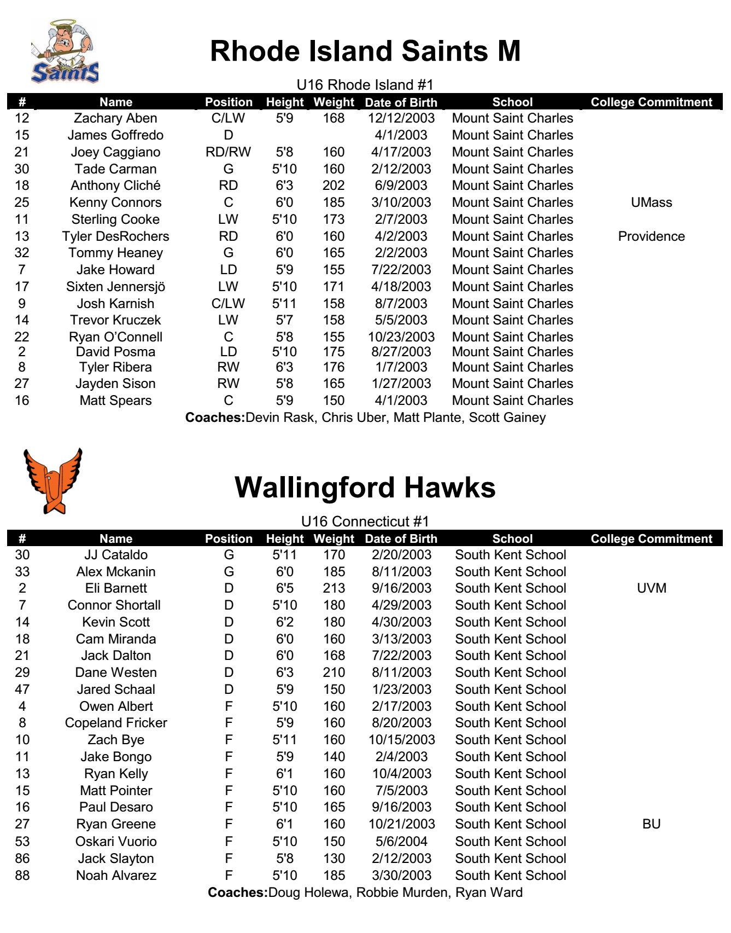

 | New England District
18U Divisions & Schedule
American Division |  |  |  | National Division
Connecticut 1 – Junior Bulldogs |  |  |  | New Hampshire 1 -Northern Cyclones 2
Connecticut 2 – Wallingford |  |  |  | New Hampshire 2 – Northern Cyclones 1
Connecticut 3 – East Haven |  |  |  | Rhode Island – RI Saints M
Friday, 11/8/19
Game # |  | Time | Rink |  | Home Team |  |  | Away Team
1 |  | 5:00 PM | 2 |  | Connecticut 1 |  |  | New Hampshire 2
2 |  | 6:00 PM | 1 |  | Rhode Island |  |  | Connecticut 3
3 |  | 6:10 PM | 3 |  | New Hampshire 1 |  |  | Connecticut 2

Saturday, 11/9/19
4 |  | 10:00 AM | 2 |  | New Hampshire 1 |  |  | Connecticut 1
5 |  | 10:30 AM | 1 |  | Connecticut 3 |  |  | New Hampshire 2
6 |  | 10:40 AM | 3 |  | Connecticut 2 |  |  | Rhode Island
7 |  | 8:00 PM | 1 |  | Connecticut 1 |  |  | Rhode Island
8 |  | 8:10 PM | 6 |  | Connecticut 3 |  |  | New Hampshire 1
9 |  | 8:40 PM | 3 |  | New Hampshire 2 |  |  | Connecticut 2
Sunday, 11/10/18
10 |  | 11:20 AM | 7 |  |  | #1 Seed | #4 Seed
11 |  | 11:40 AM | 8 |  |  | #2 Seed | #3 Seed
12 |  | 6:20 PM | 2 |  |  | Championship Game

